**CMPE-273 Lab1 Calculator and Homeaway prototype using React, MYSQL and Node**

**Nirbhay Kekre (git repo:** [**https://github.com/Anuragis/CMPE273-37**](https://github.com/Anuragis/CMPE273-37) **)**

**Goal:**

1. To understand the client server architecture by creating an calculator application.
2. The purpose of this lab is to learn and understand the concepts of distributed computing using React, node and MySql.

**System Design:**

1. **Calculator:**
   1. The system implements RESTful services
   2. Node.js with express is used at the back-end to create routes
   3. React is used for front-end to render the user interactive calculator input page
   4. System provides basic operations like addition, subtraction, multiplication, division which can be routed to backend to evaluate the expression.
2. **Homeaway prototype:**
3. This System is created using React, Node and Mysql
4. The server has implemented REST services using Nodejs.
5. The backend server provides routes for various functionalities like:
   * log in for traveler/owner of property
   * Sign up
   * Logout
   * Create profile
   * Update profile
   * Search Properties – the system can also handle various filter criterias like min number of bedrooms, city in which you want property. It also supports sorting of results based on price and bedroom count.
   * Create property
   * See detail view of property and Book properties
   * Owner can view dashboard with all posted properties and all sold properties.
   * System also Encrypts/ Decrypts the password.
   * Session Handling is done using express-session and cookie-parser.
   * System interacts with MySql server for persisting the data
6. The frontend is created using React has several reusable components to implement interactive pages for all the functionalities mentioned above.
7. The system is robust and secure as passwords are encrypted using bcrypt.
8. The application is horizontally scalable.
9. **Results**

**3.1. Calculator:**

**3.1.1. Request:** Expression is createdusing +, - * and / operator buttons.

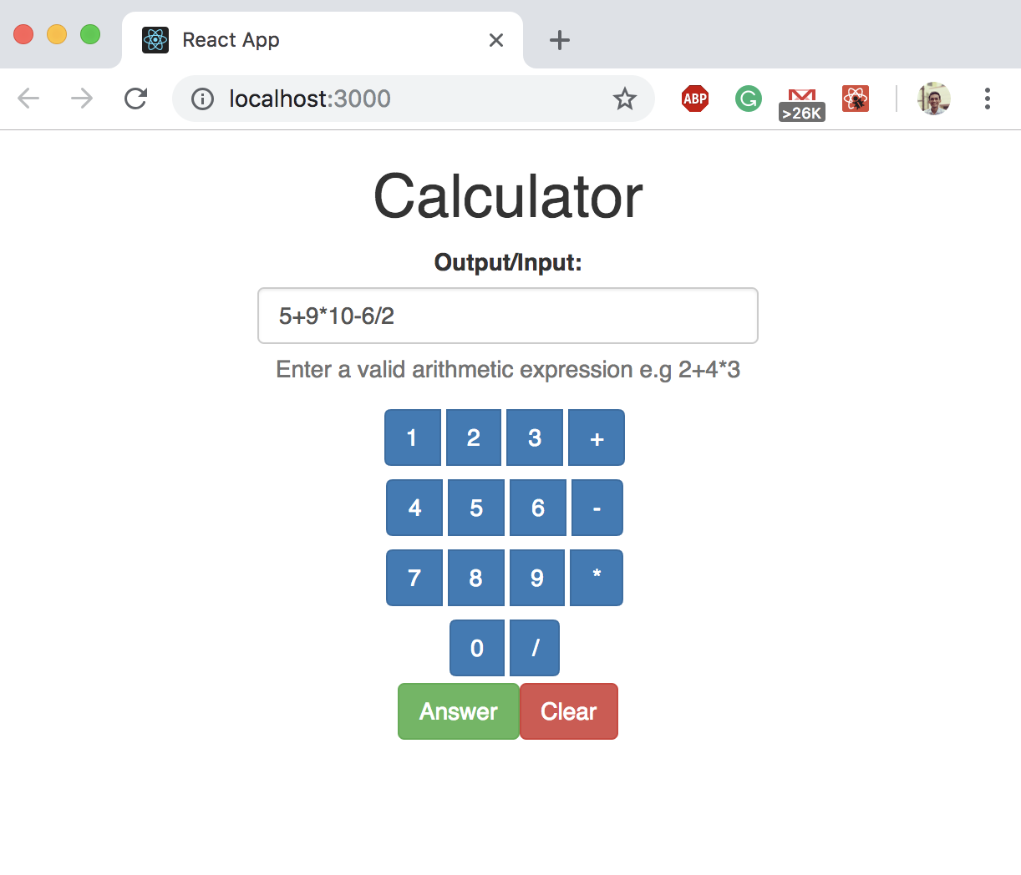

**3.1.2. Response:**

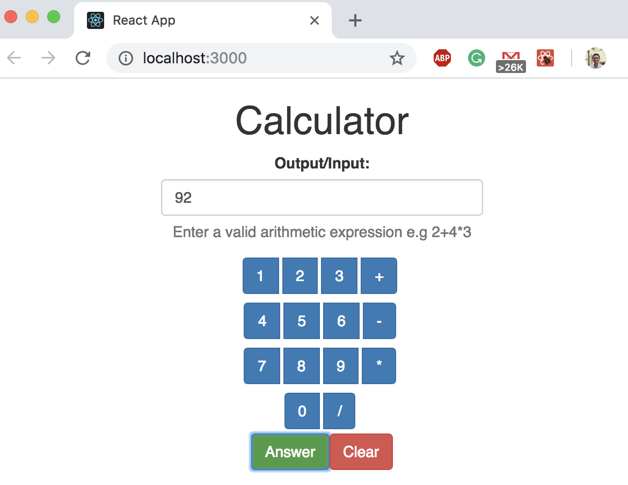

**3.1.3. J-meter performance testing:**

Graph Result for 1000 concurrent users with one request each:

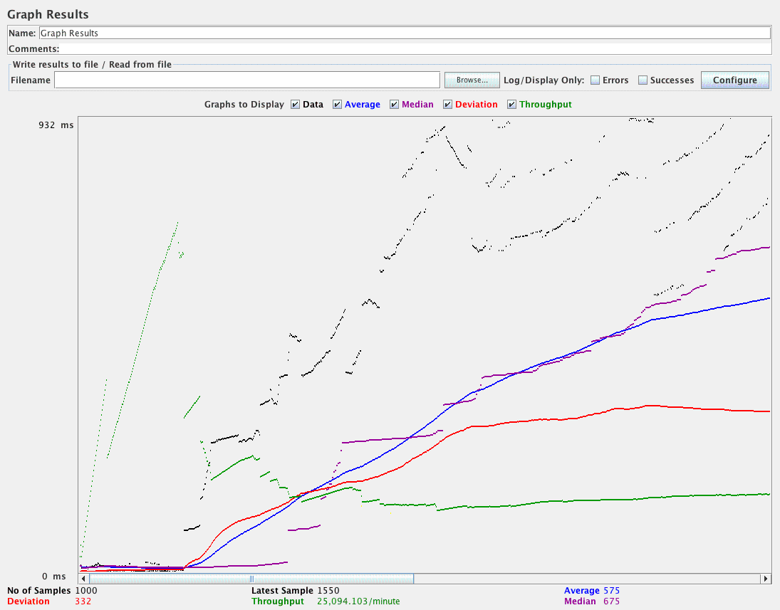

Aggregate report for 1000 concurrent users with one request each:

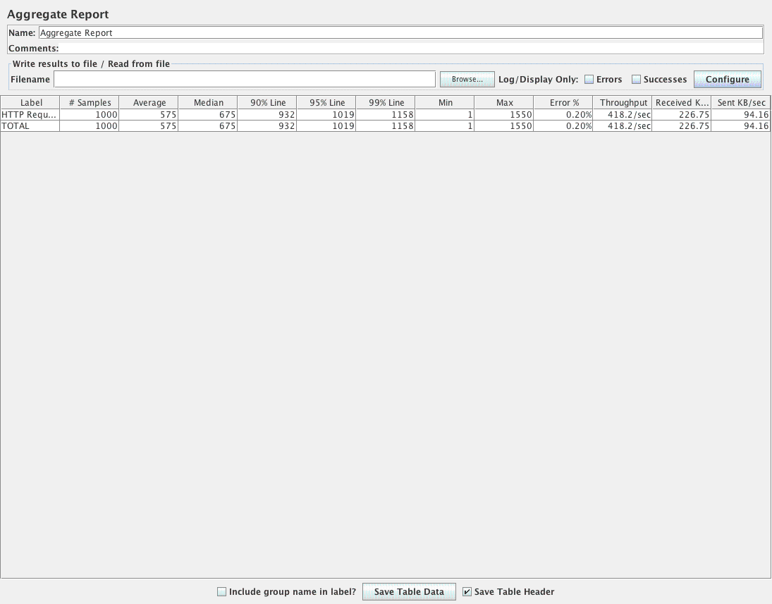

Aggregate graph for 1000 concurrent users with one request each:

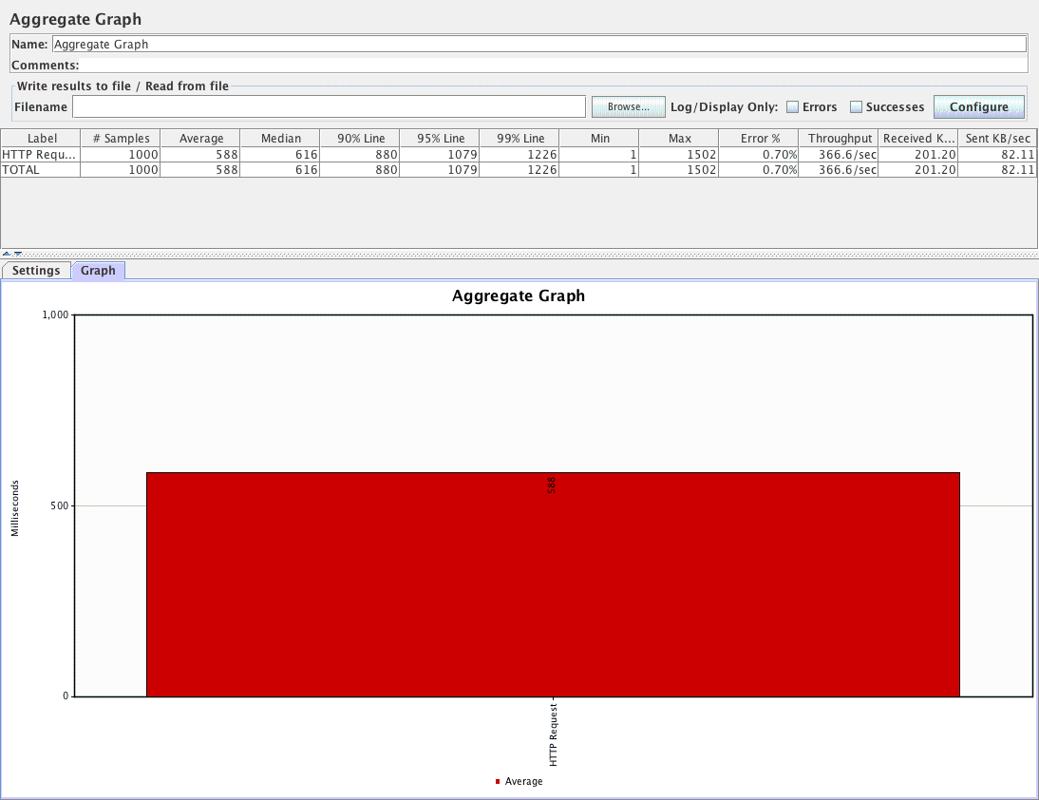

Graph Result for 5000 concurrent users with one request each:

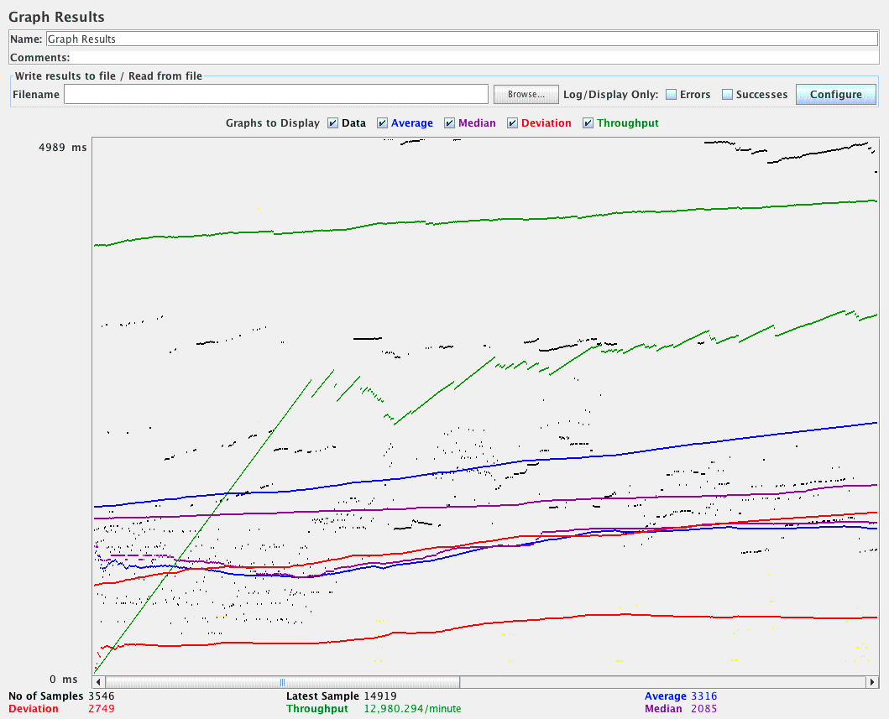

Aggregate report for 5000 concurrent users with one call each:

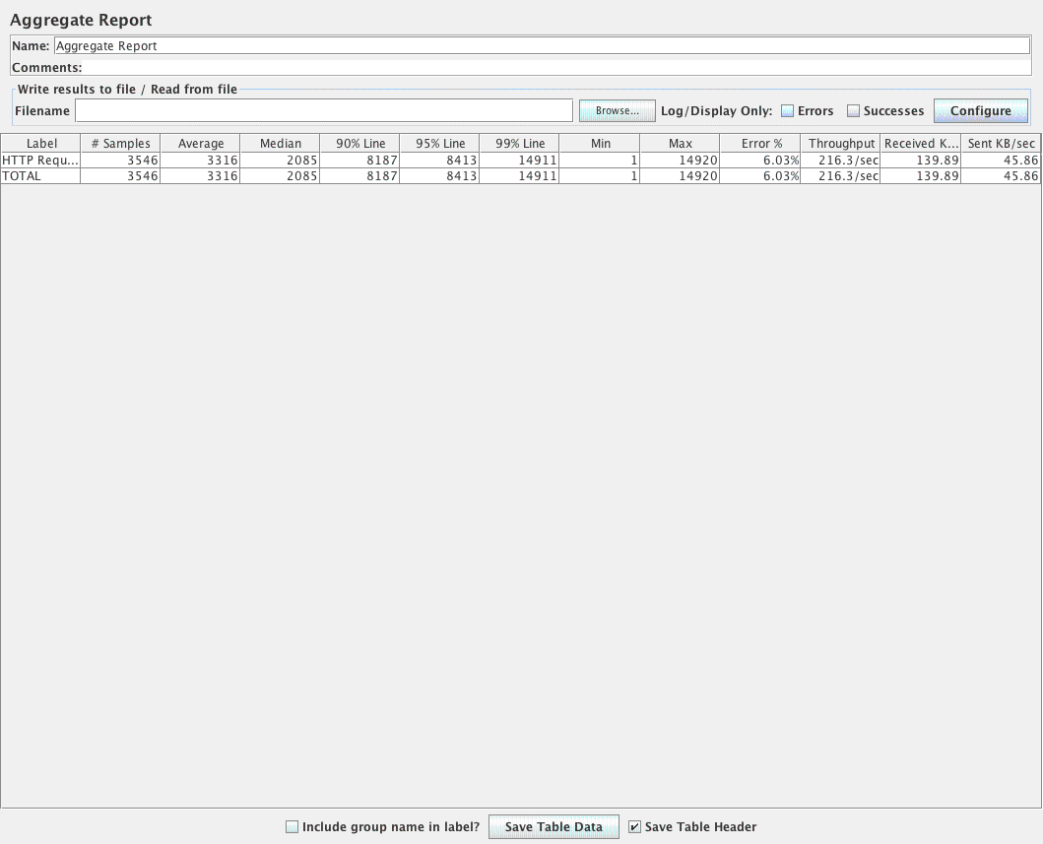

Aggregate graph for 5000 concurrent users with one call each:

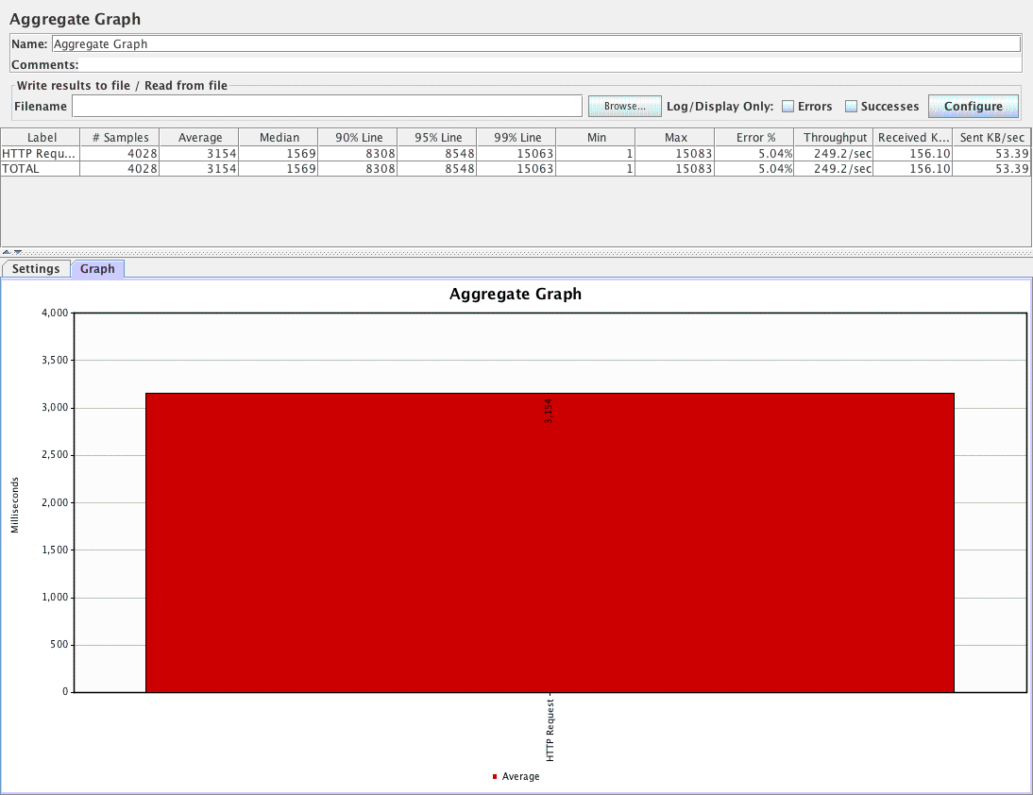

Graph Results 100 concurrent users with 1000 calls each:

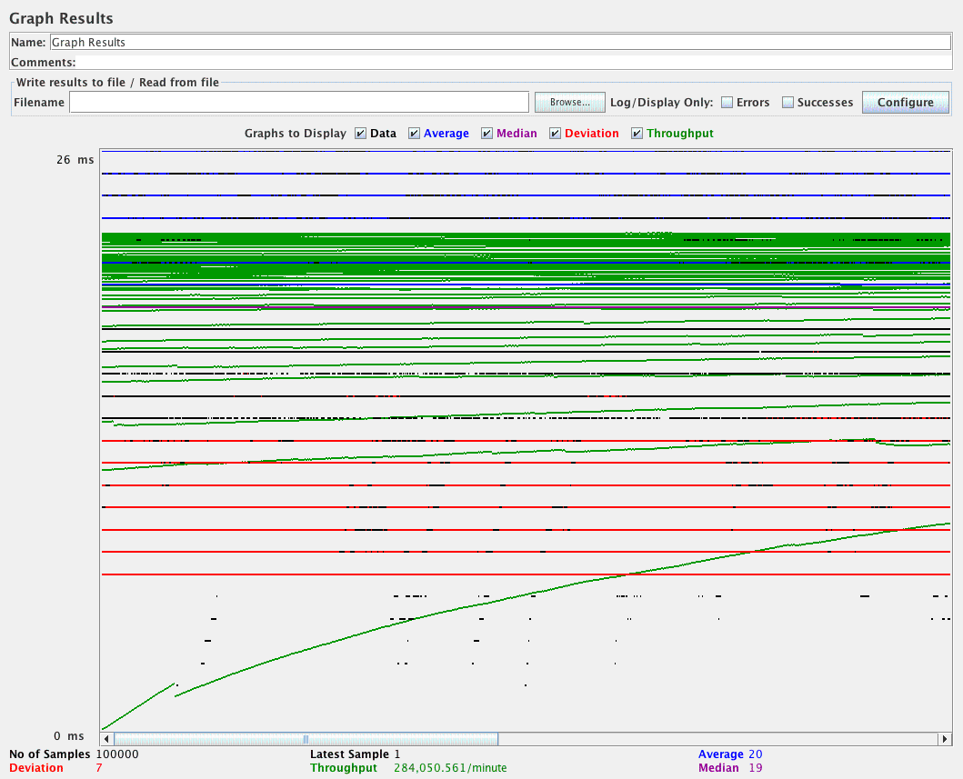

Aggregate report for 100 concurrent users with 1000 calls each:

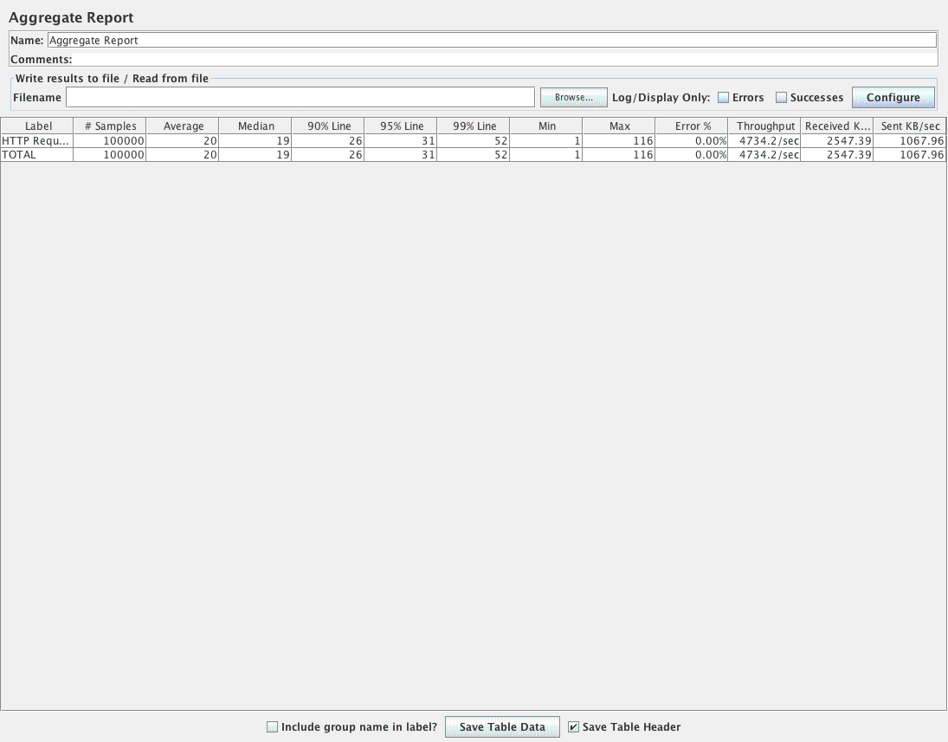

Aggregate Graph for 100 concurrent users with 1000 calls each:

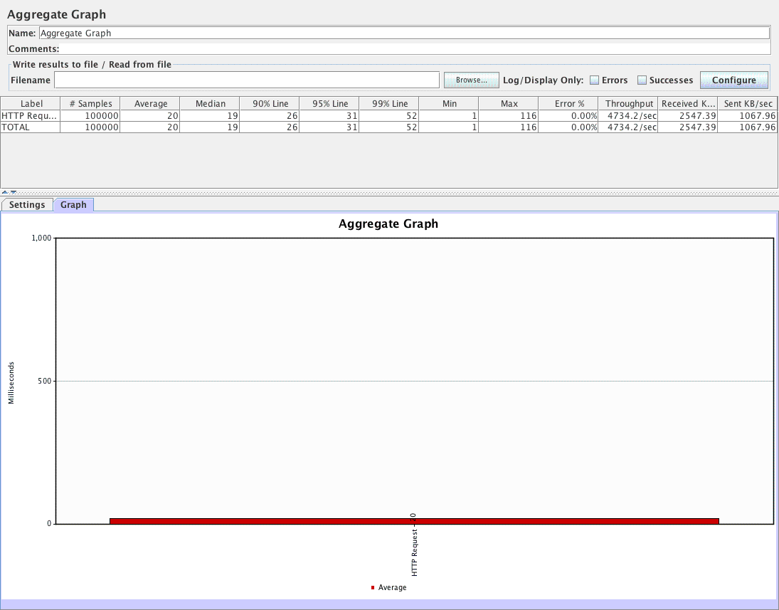

**3.2. Homeaway results:**

**Signup:**

There is only one signup page user can later decide to become an owner, first time all will be traveler.

We can reach to signup page by clicking traveler login:

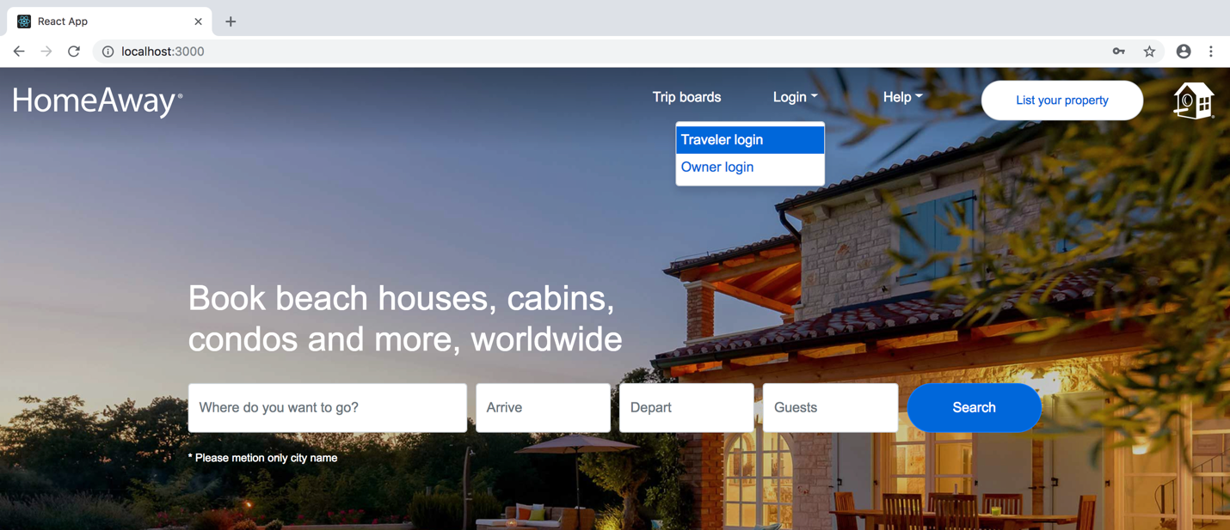

Then click on signup link :

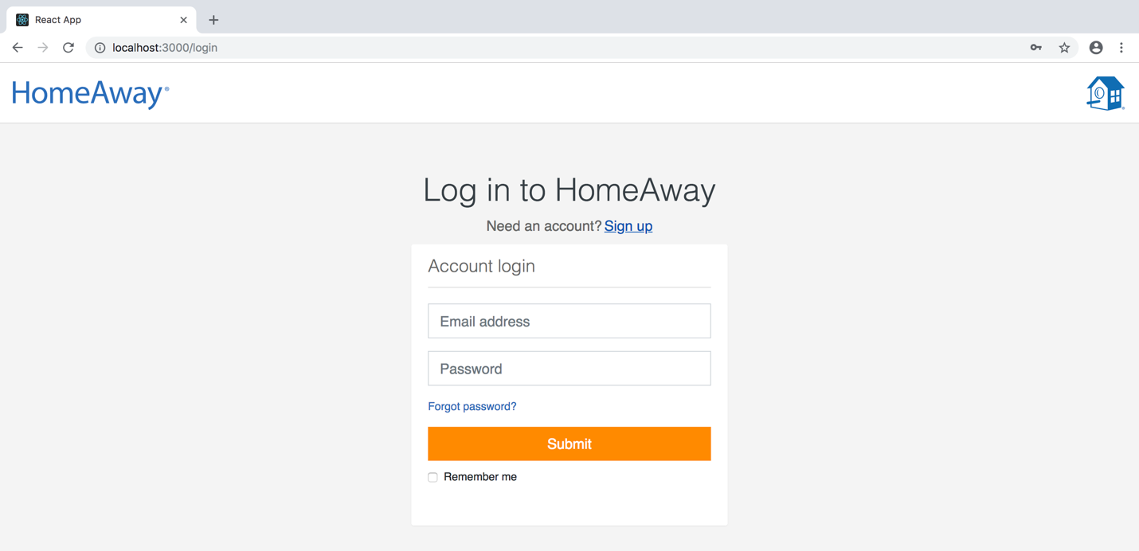

On clicking signup link:

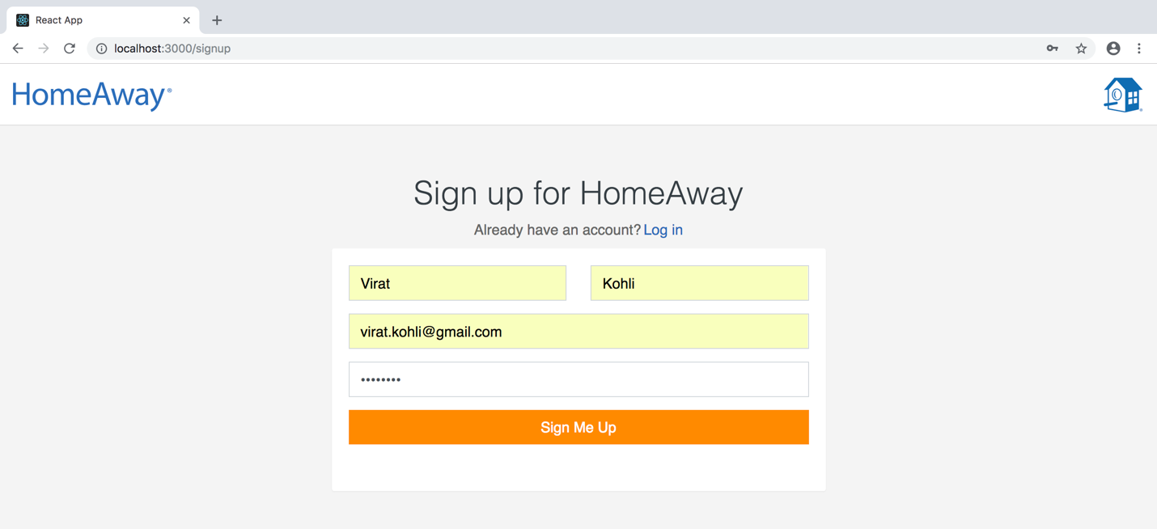

Now it will ask either to continue or update profile:

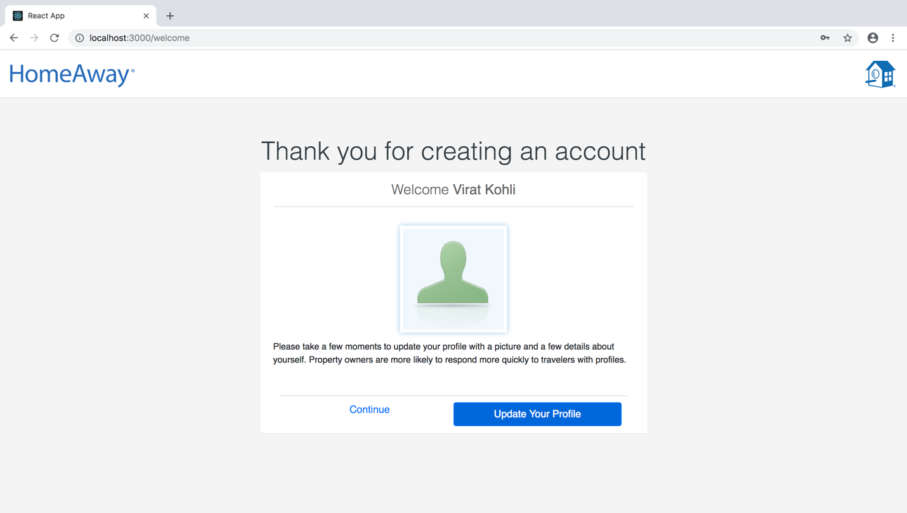

For now let’s continue to home page, we will cover edit profile later in this document.

**Search and book property:**

* Here if user searches any property without logging in will be redirected to traveler login page
* Once logged-in upon searching the city the user will get list of available properties.

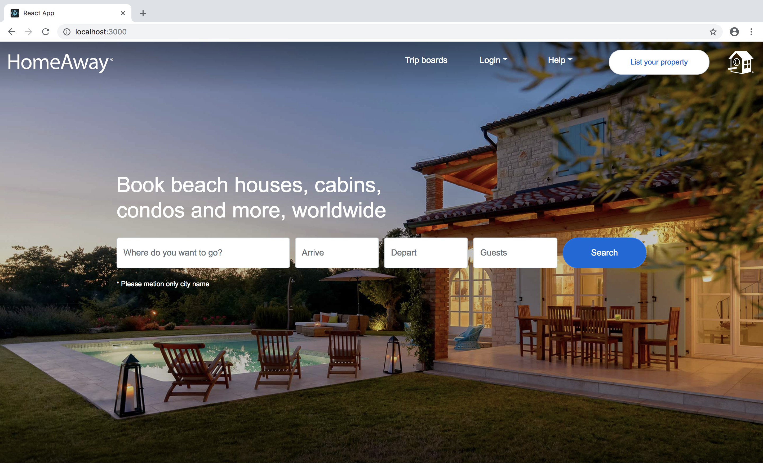

Selecting traveler/owner login option (I am selecting traveler login):

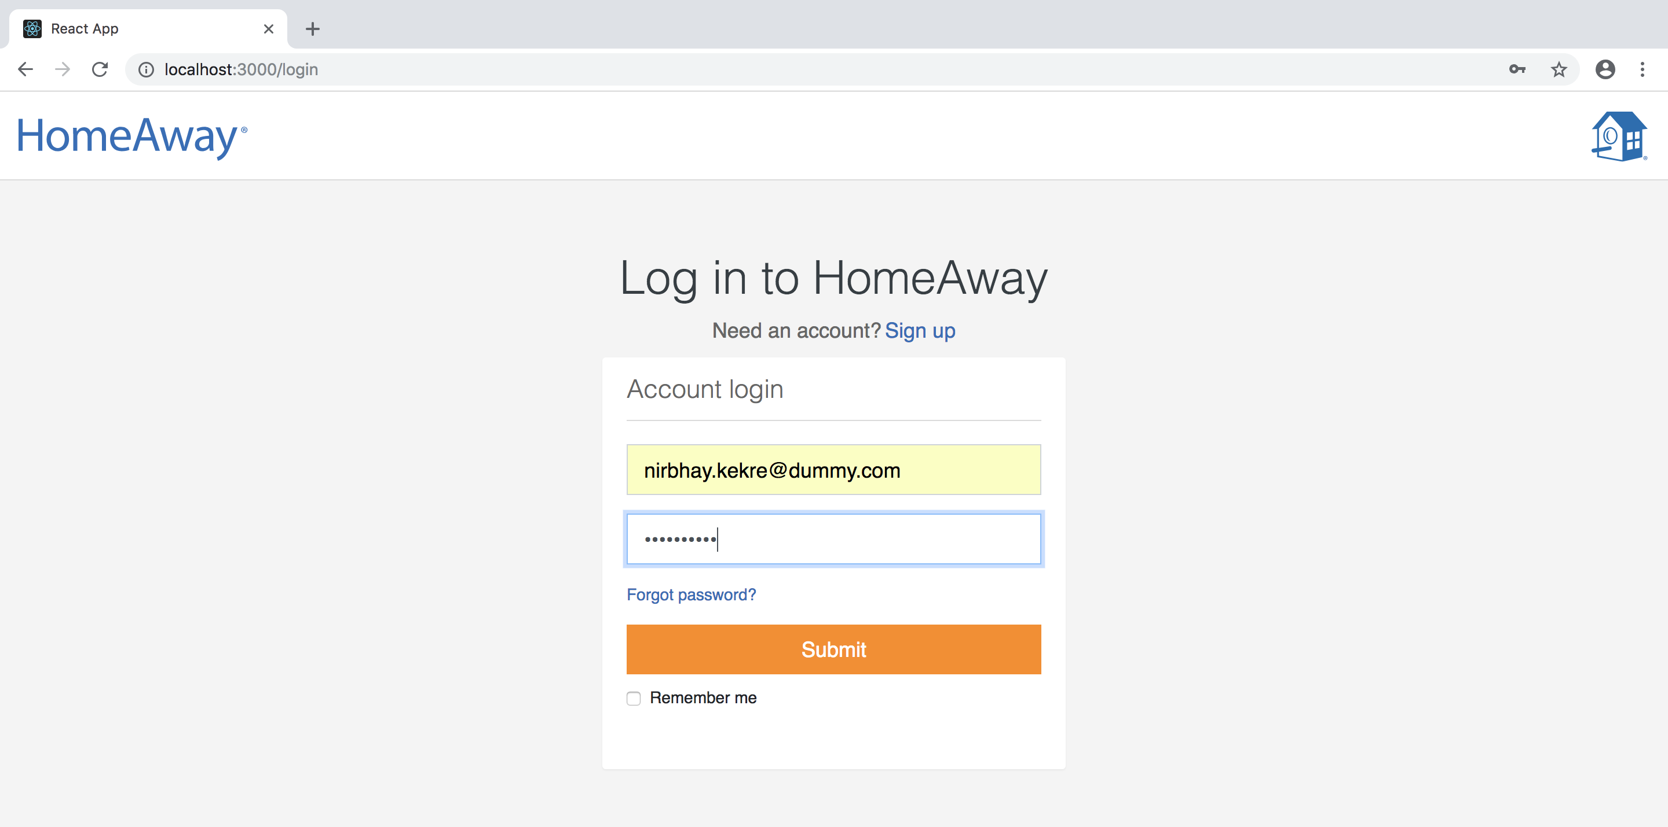

Let’s Try searching for san jose:

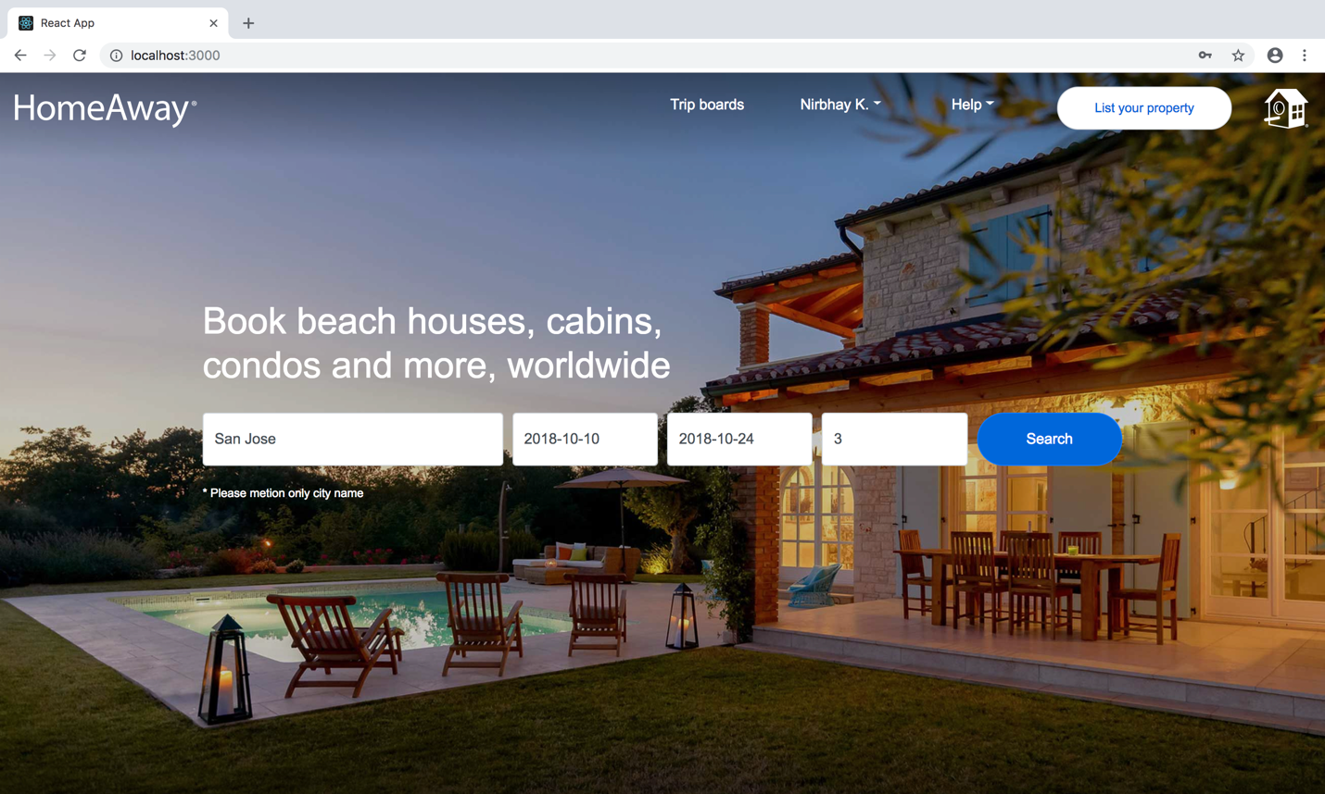

On clicking search:

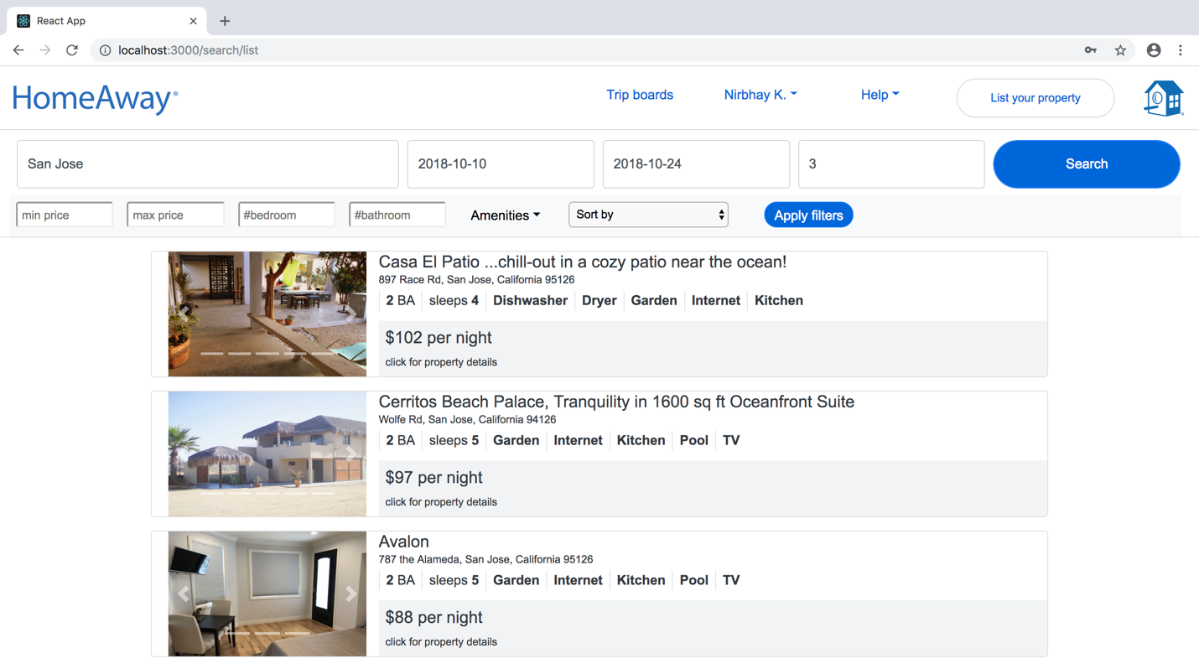

On selecting a property: (note I zoomed out for full view)

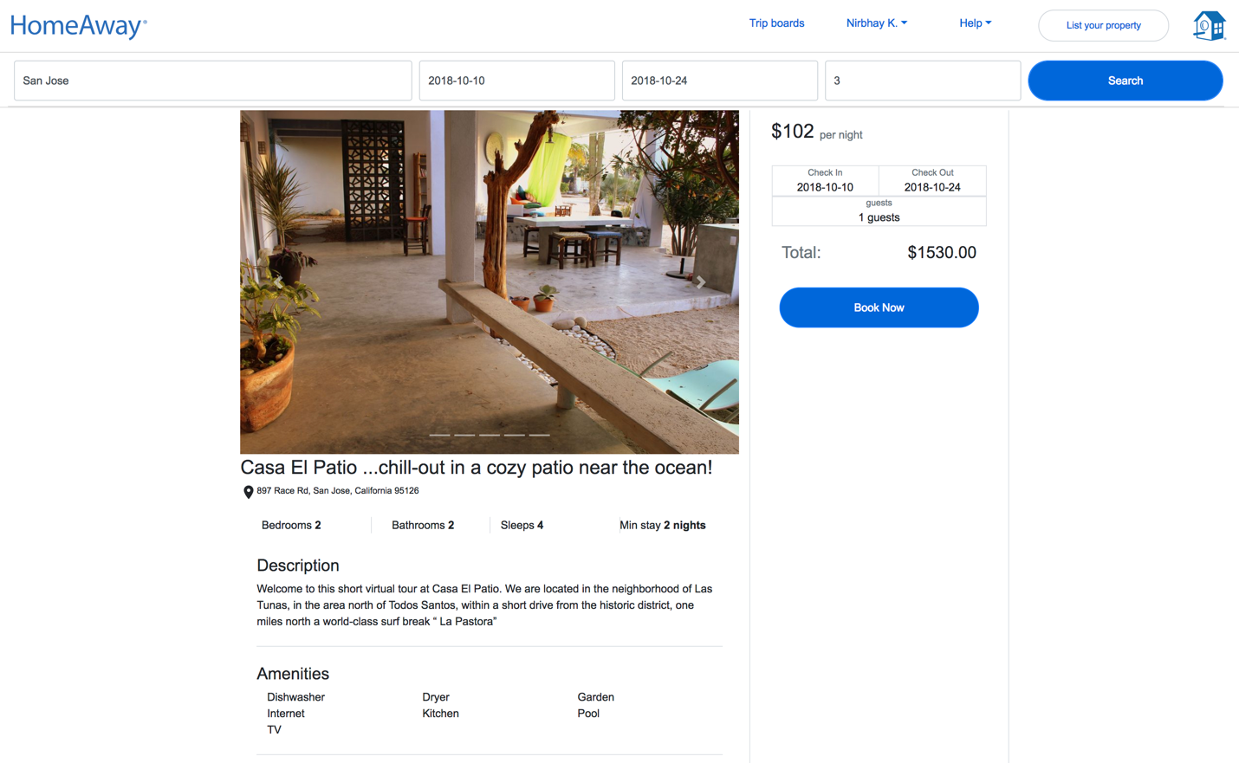

On clicking book now:

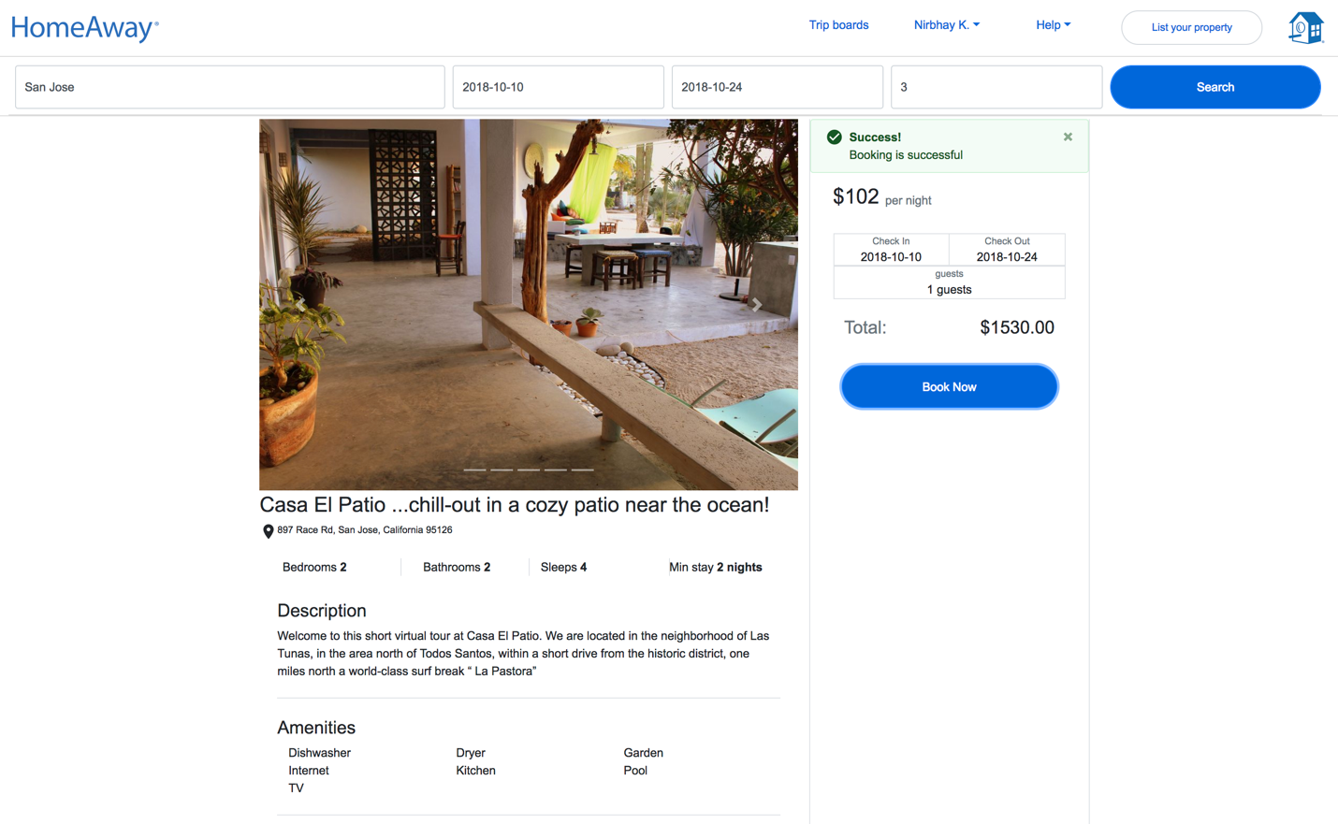

Now lets check our planned trips, by clicking “My trips” option:

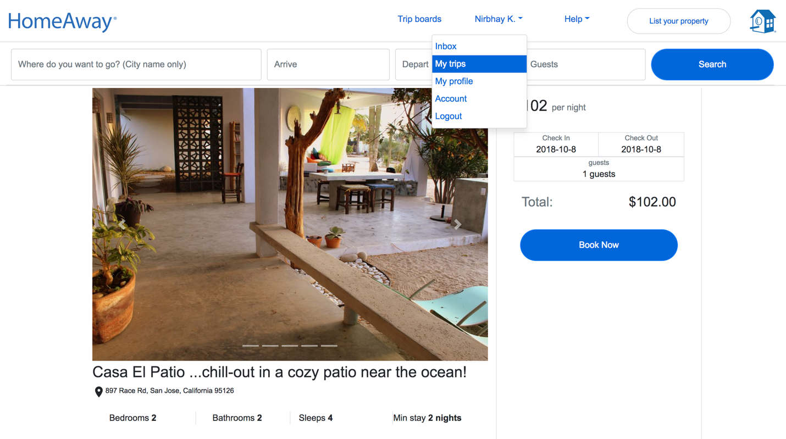

Here is our planned trips and history:

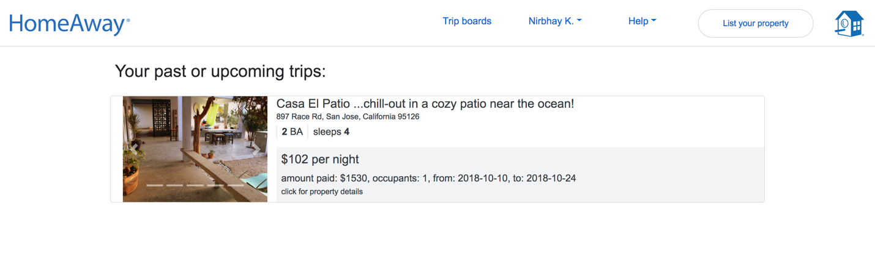

**Edit and view Profile**

We can go to view profile by clicking my profile option on navbar:

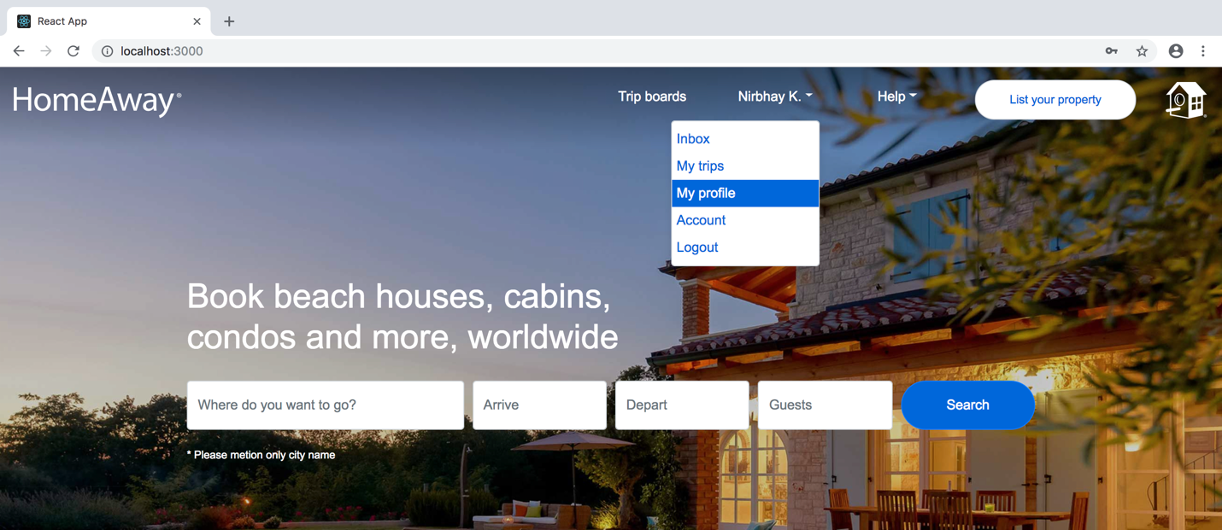

It take us to view profile page:

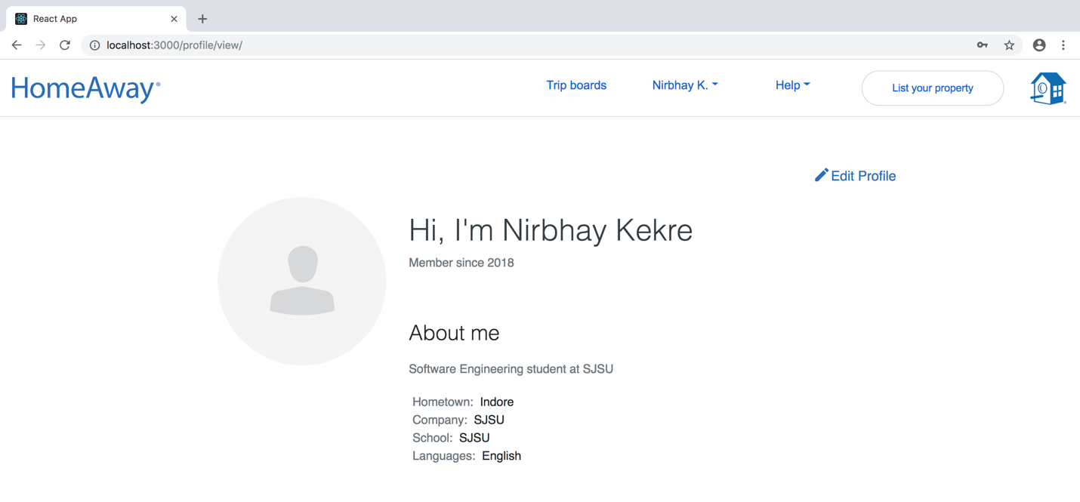

We can click on Edit profile to edit our profile, I am adding my profile pic here:

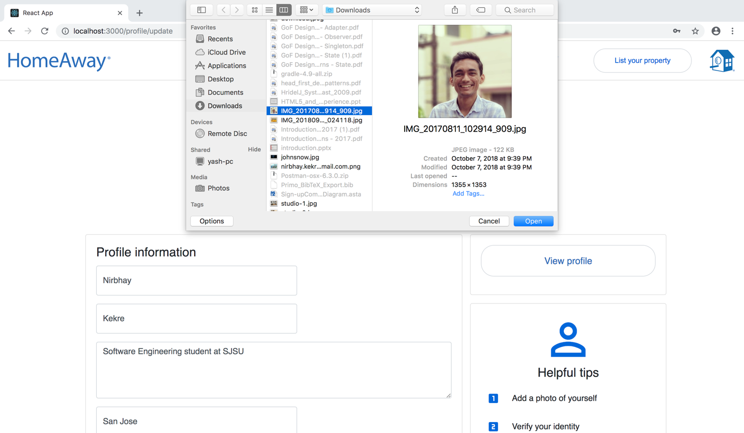

On clicking save :

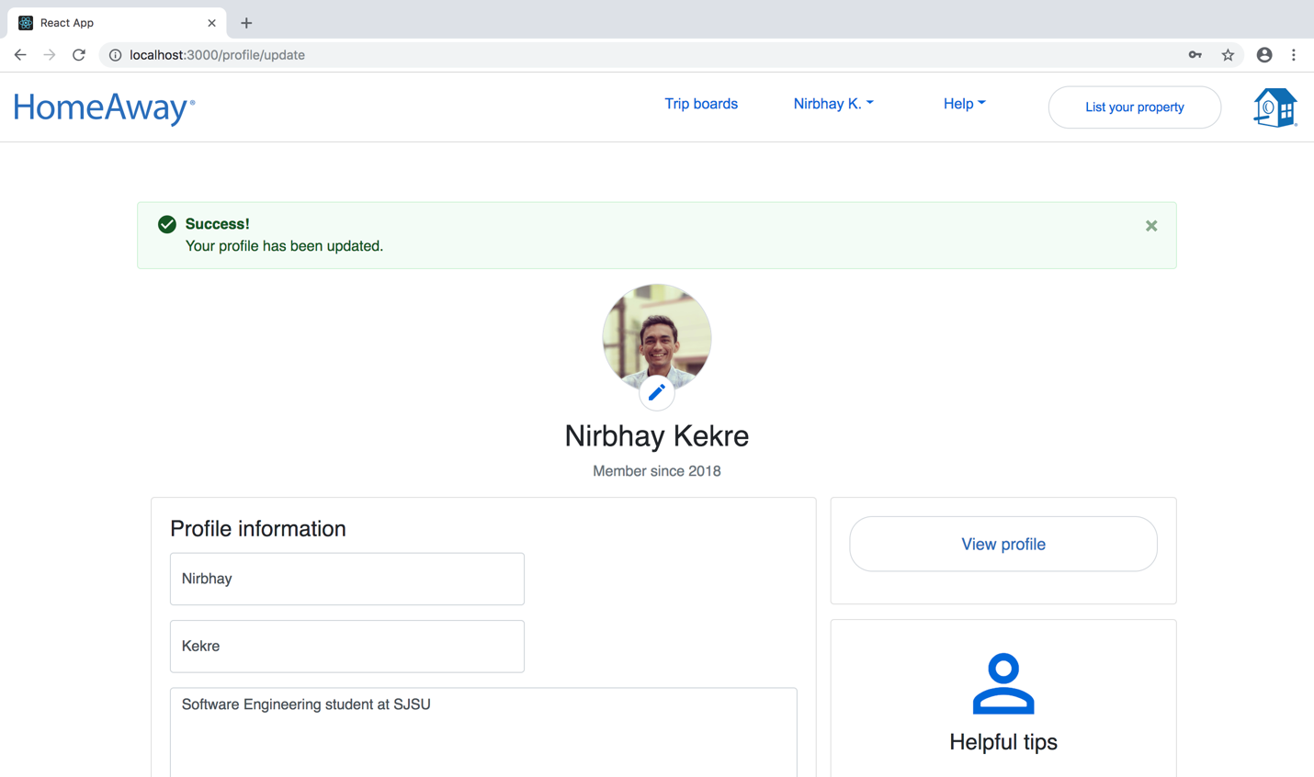

Now On view profile we can see these changes:

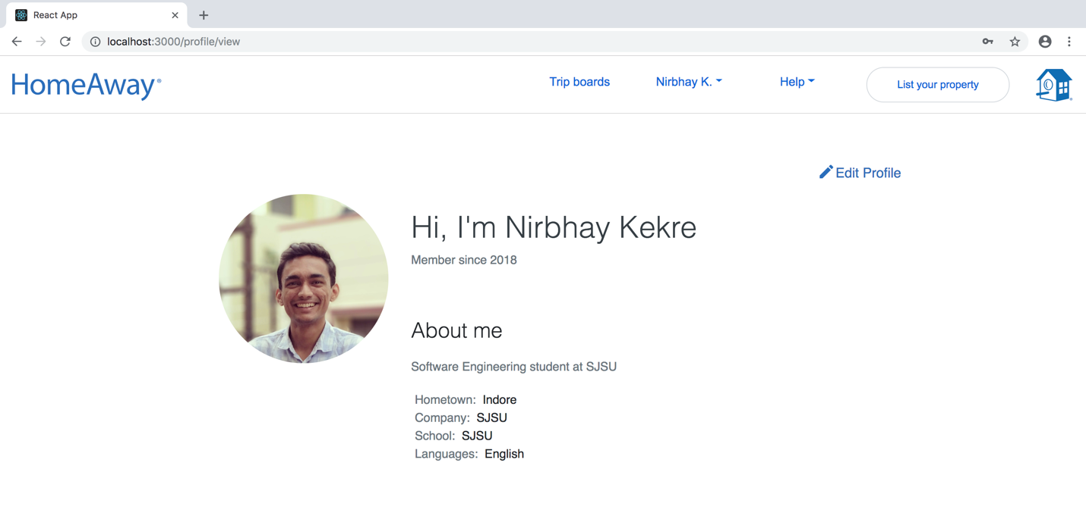

Posting a property:

Lets login with another user (“Ravindra jadeja”), and click List property on the top navbar, since the user is not a owner yet we will ask him to confirm whether he wants to be an owner.

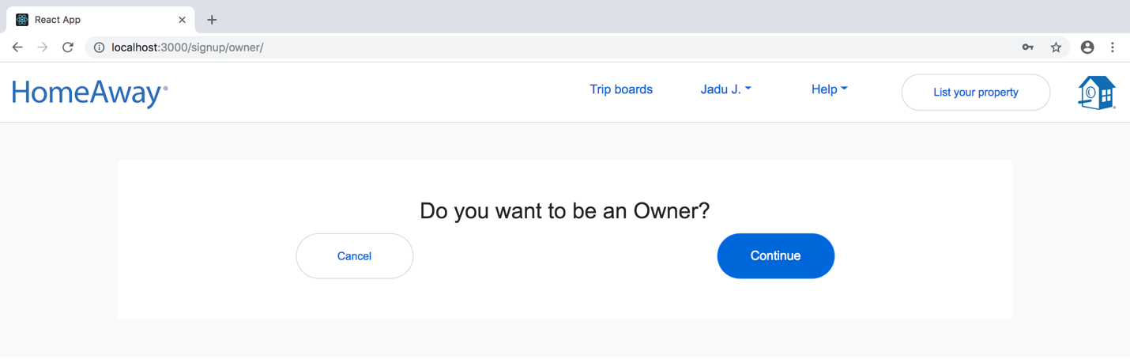

On clicking continue, we are on post property page:

Add location details:

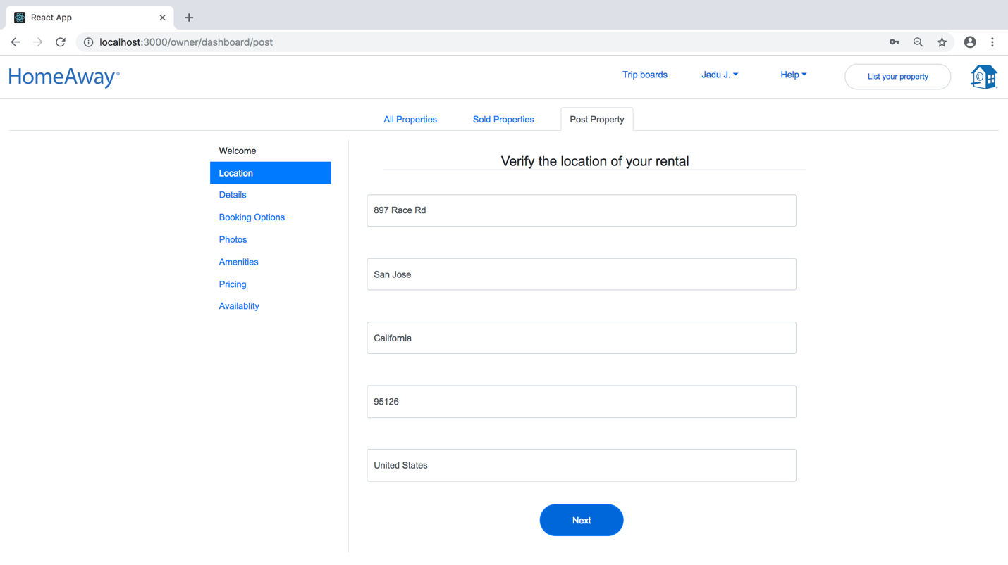

Add details about property:

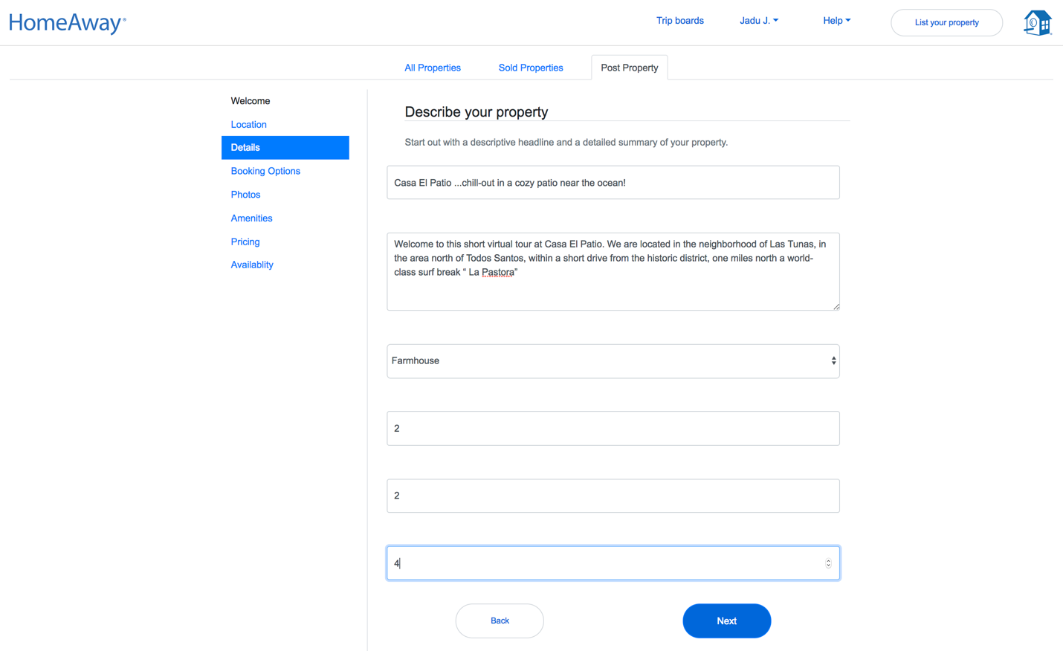

Add Booking option:

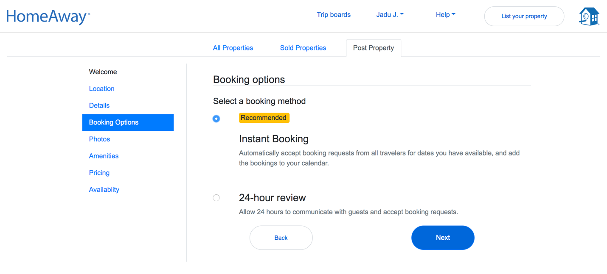

Add photos of property min 2 and max 5:

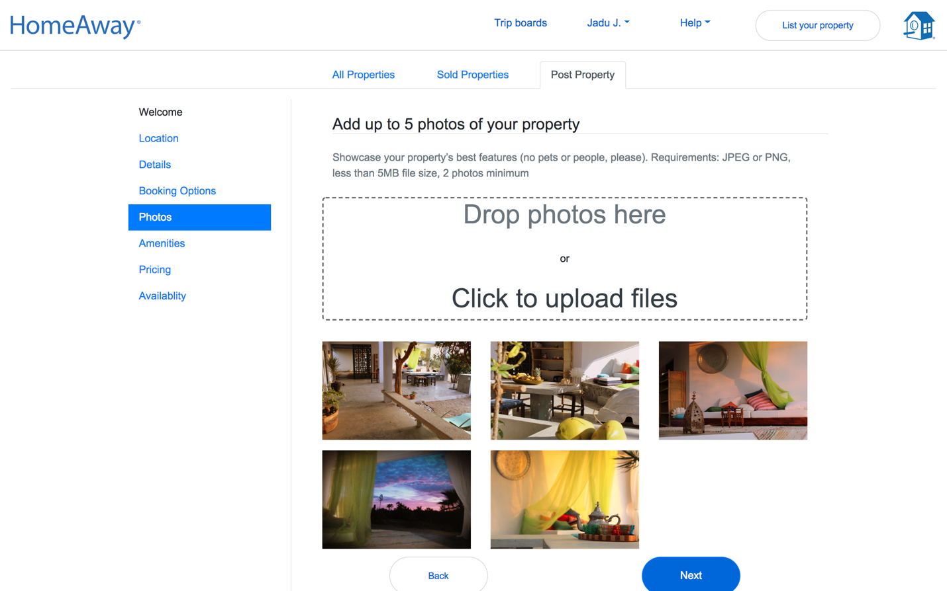

Amenities:

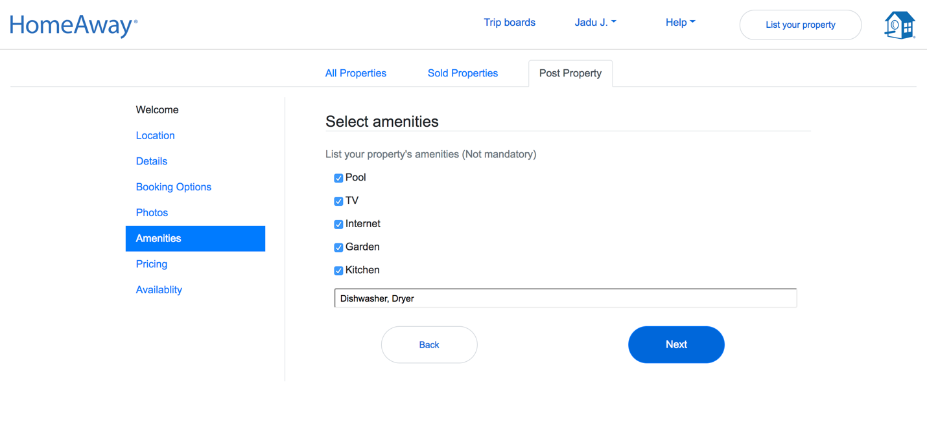

Pricing:

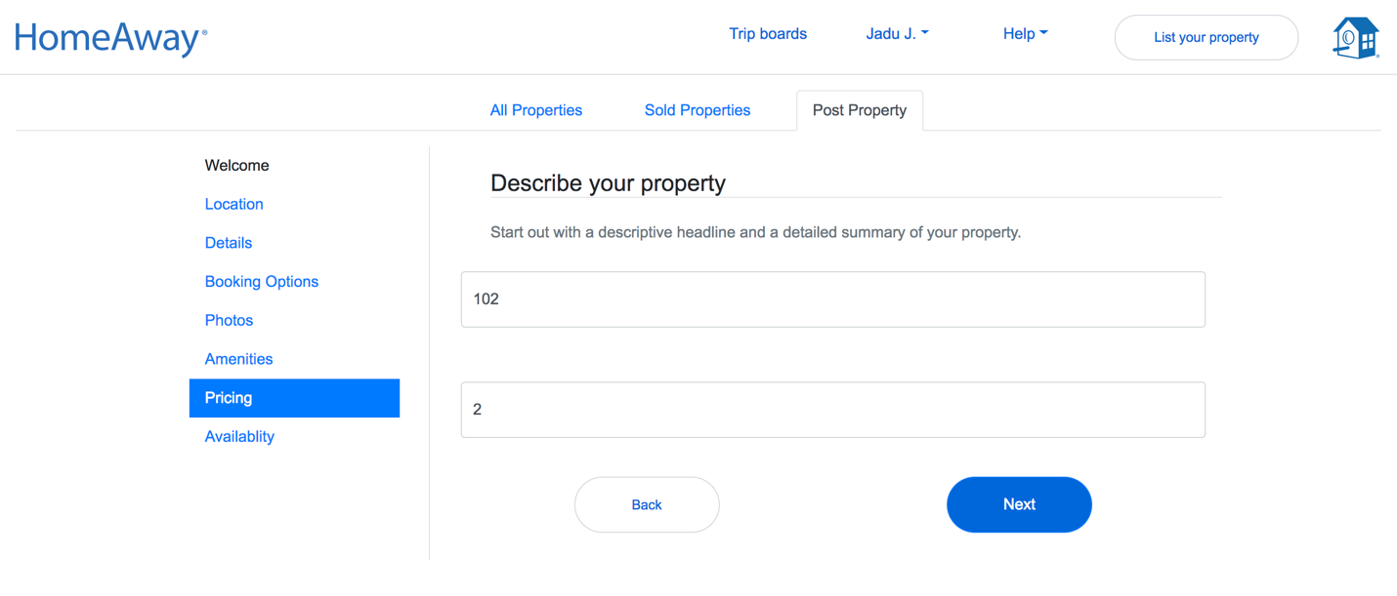

Availability dates for property:

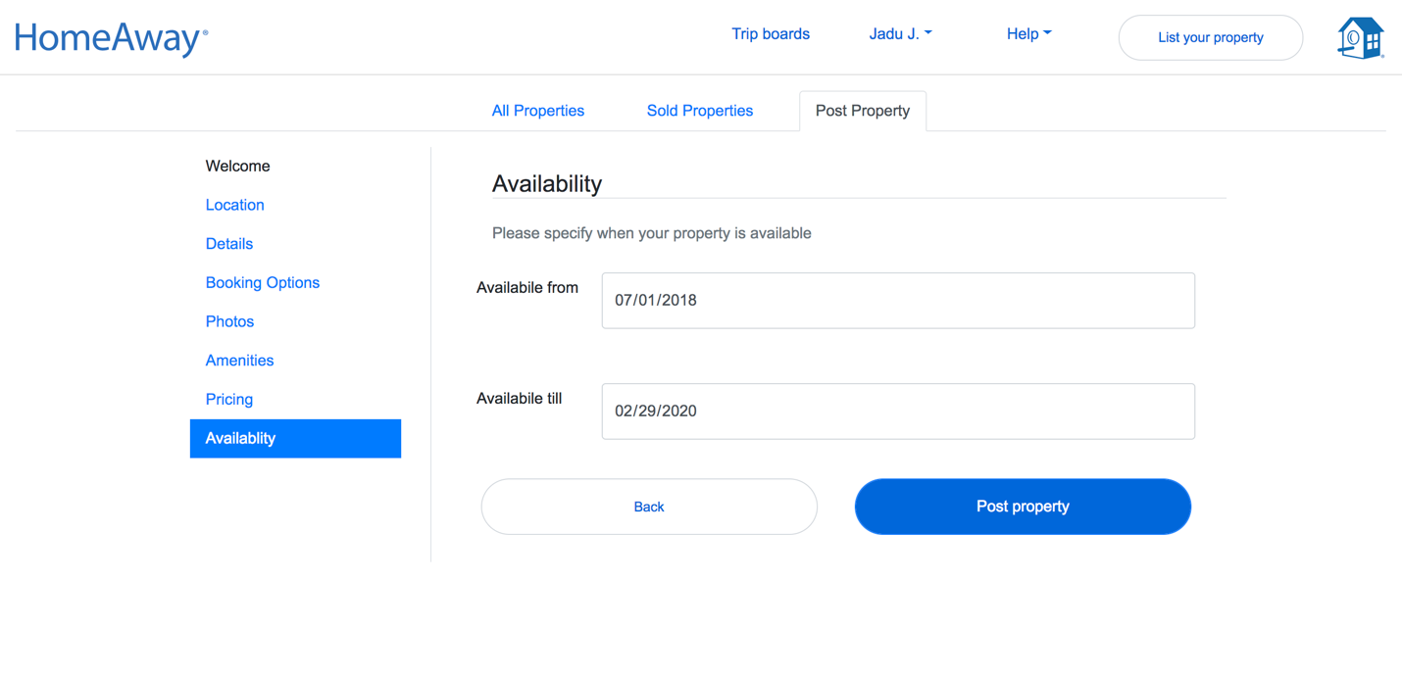

On clicking post property our property will be posted.

**Owner dashboard: (We can go to dashboard by selecting it from navbar)**

All listed properties:



All sold properties: (we can see who booked our property)

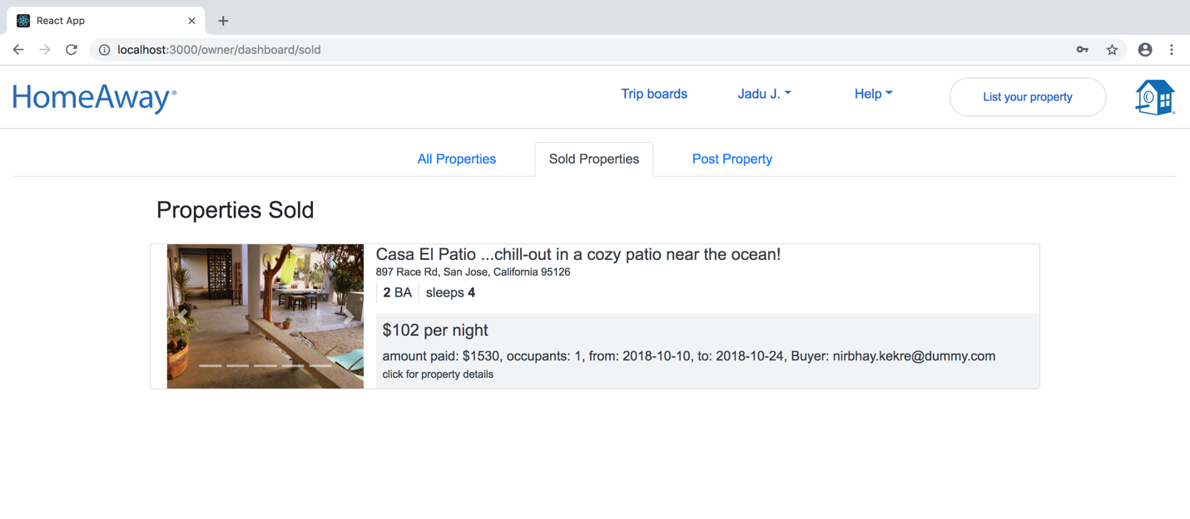

**Questions:**

1. **Explain the encryption algorithm used in your application. Mention different encryption algorithms available and the reason for your selection of the algorithm used?**

**Ans**.-

* Backend server encrypts and decrypts the password using bcrypt algorithm.
* Another encryption Algorithm which I could have used are MD5 (Message digest 5), AES, SHA
* MD5 can create a hash for short bit passwords with higher bit hash. But this algorithm is fast it doesn’t take constant time which can be used by a hacker to crack it easily. While bcrypt takes constant time and it is slow enough to make it impossible for hacker to try all possibilities of passwords but it fast enough to work on production system.
* SHA is a predictable algorithm while bcrypt uses salt before encrypting which makes the encrypted password less predictable.
* Bcrypt is the robust encryption till date and has not been broken yet. Hence, I chose it above other.

1. **What is SQL caching? What all types of SQL caching are available, and which suits your code the most. You don’t need to implement the caching, write pseudocode or explain in detail.**

**Ans.**

* Hard drives or disk storages are slower than a RAM or memory or L1, L2 caches.
* SQL server has buffer pool, which is an area in Memory, the read write operation on the buffer pool is faster.
* SQL server caches the queries with their corresponding results, Tables and Indexes in the buffer pool. Hence when a user tries to query the database it can retrieve the results faster if available in cache.
* To further optimize the application, we can cache the results in application, but this brings the overhead on application to invalidate the cache.
* SQL caching/ buffer pool can be extended further to SSD drives to increase the cache size.
* When cache gets full it will clear the older search results from the cache memory.

1. **Is your session strategy horizontally scalable? If YES, explain your session handling strategy. If NO, then explain how you can achieve it.**

**Ans.**

* **No,** currently my session strategy is not horizontally scalable **because I am storing session information in memory of the application**.
* If we scale the current implementation of server then, other instances of our distributed application will not have access to the session object which will fail the authentication.
* To horizontally scale the server, we need to store the session data in a persistent storage, which can be accessed throughout our distributed application.
* PassportJS and JWT token are good candidates for implementing this solution to scale.
* PassportJS will store and manage the session object in a MySql or other persistent storage. So, whenever a call comes to any of the server instance it can access the session object to authenticate.
* But using passport Js alone will not help if our persistent storage itself is distributed, because then there might be cases when a session is store in a DB instance, but it is not replicated yet to other DB Instances.
* Hence using JWT token with passport JS can solve this problem because the token will be generated once when the user is created. And every time the user logs in the application will encrypt the token with private key.Since, here our DB is not changing every time the user logs in it solves the problem stated above.

**Database Dump is available at :**

[**https://github.com/Anuragis/CMPE273-37/tree/master/backend/Schema_DDL/Dump**](https://github.com/Anuragis/CMPE273-37/tree/master/backend/Schema_DDL/Dump)